**Prevalence of overweight and obesity among COVID-19 hospitalized patients in Southern region Noakhali & Laksmipur, Bangladesh**

Md. Aminul Islam1,2*, Abdullah Al Marzan3, Mohammad Nayeem Hasan4, Shatila Shahi4, Mohammad Ruhul Amin1, **Rahima Begum5, Sourav Roy6, Kuldeep Dhama7, Mohammad Salim Hossain7,** Prosun Bhattacharya8\***, Firoz Ahmed1\***

1Advanced Molecular Lab, Department of Microbiology, President Abdul Hamid Medical College, Karimganj, Kishoreganj-2310, Bangladesh  
2COVID-19 Diagnostic lab, Department of Microbiology, Noakhali Science and Technology University, Noakhali-3814, Bangladesh  
3Department of Biochemistry and Molecular Biology, Shahjalal University of Science and Technology, Sylhet, 3114, Bangladesh

4Department of Statistics, Shahjalal University of Science and Technology, Sylhet 3114, Bangladesh.

5Department of Pharmacy, Ranada Prasad Shaha University.

6Department of Pharmacy, Noakhali Science and Technology University, Noakhlai 3814, Bangladesh

7Division of Pathology, ICAR-Indian Veterinary Research Institute, Bareilly, Uttar Pradesh – 243122,14 India

8COVID-19 Research @KTH, Department of Sustainable Development, Environmental Science and Engineering, KTH Royal Institute  
of Technology, Teknikringen 10B, SE-100 44 Stockholm, Sweden

**\*Corresponding Author**aminul@pahmc.edu.bd/aminulmbg@gmail.com, firoz@nstu.edu.bd, prosun@kth.se

**List of supplementary tables:**

**Table ST 1:** Clinical sample collection questionnaire

**Table ST 2:** PCR conditions, cycling, gel run condition

**List of supplementary Figures:**

Figure SF1: Quality control of kits

Figure SF2: COVID-19 status of Bangladesh

**Table ST 1:** Clinical sample collection questionnaire

**Questionnaire**

**Personal Details:**

|  |
| --- |
| GC of respondent/ Lab identification number: |
| Name of respondent (as per test at NSTU) |
| Mobile number: Own (Provided for test) |
| Family Member: |
| Permanent Address: |
| Present Address: |
| Code Number: |
| Do you consent to participate in the study: Yes/No |
| Interviewer Signature with date: |

**1. Socio-demographic information:**

|  |  |  |
| --- | --- | --- |
| Question and filters | Response |  |
| 1.1 | Age | …………..Years |
| 1.2 | Gender (Put √ on your answer) | 1 = Male  2 =Female |
| 1.3 | Marital Status (Put √ on your answer) | 1 = Married  2 = Unmarried  3 = Widow/ Widower  4 = Divorce |
| 14 | Educational Status (Put √ on your answer) | 1 = No formal education  2 = Primary education  3 = Secondary education  4= Higher secondary  5 = Bachelor or above |
| 1.5 | Occupation (Please write) |  |
| 1.6 | Living area (Put √ on your answer) | 1= Rural  2 = Semi Urban  3 = Urban |
| 1.7 | Average monthly family income (Please write) |  |
| 1.8 | Number of family members (Please write) |  |

**2. Covid-19 related information:**

Before Starting, please mention your Blood group:

|  |  |  |
| --- | --- | --- |
| 2.1 | When did you diagnose COVID Positive? (Please write the date) |  |
| 2.2 | How long you were in isolation? (Please write) | ………….days |
| 2.3 | Had you been admitted to the hospital? (If yes, mention the duration….days) | 1=Yes  2=No  (if yes, mention the duration ………..days) |
| 2.4 | Days from symptom onset to hospital admission (Please write) | ………….days |
| 2.5 | Diagnosed COVID-19 in the family? (Put √ and write your answer) If Yes, mention the number of affected family members…) | 1=Yes  2=No  (if yes, mention the number of your affected family members……………..) |
| 2.6 | Diagnosed COVID-19 in the community? (Put √ on your answer) | 1=Yes  2=No |
| 2.7 | Diagnosed COVID-19 in the working area? (Put √ on your answer) | 1=Yes  2=No |
| 2.8 | Did you have a smoking history before diagnosed COVID positive? (Put √ on your answer) | 1=Yes  2=No |
| 2.9 | Did you have a travel history before diagnosed COVID positive? (Put √ on your answer) | 1=Yes  2=No  (If yes, mention the name of the country……….) |
| 2.10 | Did you visit the lockdown area/affected area in Bangladesh before diagnosed COVID positive? (Put √ and write your answer) | 1=Yes  2=No  (If yes, mention the name of the area……….) |
| 2,11 | What kinds of treatment you have received during COVID-19 status? 1= Medicine 2 = Ventilation 3= Oxygen supplementation | 1= Medicine  2= Ventilation  3=Oxygen supplementation |
| 2.12 | Did you have to admit in ICU for COVID-19? | 1=Yes  2=No |
| 2.13 | Did you receive COVID-19 vaccine?  (If yes, write vaccine name and doses) | 1=Yes  2=No |

**3. COVID-19 Symptoms: What were your symptoms? (Put √ on your answer)**

|  |  |  |
| --- | --- | --- |
| 3.1 Fever | 1=Yes | 2=NO |
| 3.2 Cough | 1=Yes | 2=NO |
| 3.3 Fatigue | 1=Yes | 2=NO |
| 3.3 Fatigue | 1=Yes | 2=NO |
| 3.4 Sputum production/ Expectoration | 1=Yes | 2=NO |
| 3.5 Headache | 1=Yes | 2=NO |
| 3.6 Diarrhoea | 1=Yes | 2=NO |
| 3.7 Myalgia | 1=Yes | 2=NO |
| 3.8 Sore throat /Pharyngalgia | 1=Yes | 2=NO |
| 3.9 Shortness of breath | 1=Yes | 2=NO |
| 3.10 Nausea or vomiting | 1=Yes | 2=NO |
| 3.11 Chill  3.12 Runny nose (Rhinorrhoea) | 1=Yes | 2=NO |
| 3.13 Dyspnea | 1=Yes | 2=NO |
| 3.14 Anorexia | 1=Yes | 2=NO |
| 3.15 Dizziness | 1=Yes | 2=NO |
| 3.16 Anosmia | 1=Yes | 2=NO |
| 3.17 Body Pain | 1=Yes | 2=NO |

**4. Self-administered Co-morbidity Questionnaire**

(If you have any of this following comorbid disease, please put √ on it. You may have multiple diseases; you can put √ on multiple points.)

|  |  |  |
| --- | --- | --- |
|  | Do you have the problem? | |
| **Problem** | No (0) | Yes (1) |
| Heart Disease | N | Y |
| High Blood Pressure | N | Y |
| Lung Disaese | N | Y |
| Diabetes | N | Y |
| Ulcer and Stomach Disease | N | Y |
| Kidney Disease | N | Y |
| Anaemia or other blood disease | N | Y |
| Cancer | N | Y |
| Depression | N | Y |
| Osteoarthritis, Degenerative arthritis | N | Y |
| Back Pain | N | Y |
| Rheumatoid Arthritis | N | Y |
| Other Medical Conditions (Specify) | N | Y |
| Medication taken | N | Y |

**5. WHO Clinical Progression Scale:**

|  |  |  |
| --- | --- | --- |
| Patient Status | Descriptor | Score |
| Uninfected | Uninfected; no viral RNA detected | 0 |
| Ambulatory mild disease | Asymptomatic ;viral RNA detected | 1 |
| Symptomatic ;independent | 2 |
| Symptomatic ;assistance needed | 3 |
| Hospitalised : moderate disease | Hospitalised ;no oxygen therapy | 4 |
|  | oxygen by mask or nasal prongs | 5 |
| Hospitalised : severe disease | Hospitalised; oxygen by NIVor high flow | 6 |
|  | Intubation and mechanical ventilation,Po2/Fio2>- 150 | 7 |
| Dead | Dead | 8 |

**Table ST 2:** PCR conditions, cycling, gel run condition

|  |  |
| --- | --- |
| **Master mix** | |
| Reaction mix : 10ul | |
| RT-enzymemix : 1ul | |
| _F : 0.8ul | |
| _R : 1.2ul | |
| Template : 7ul | |
|  | |
|  | |
| **RT-qPCR conditions** | |
| Temperature | Time |
| RT 55°C  Initialdenaturation 95°C | 12 min  1 min |
| **Cycling part (40 cycles):** | |
| Denaturation 95°C  Annealing 58°C  Extension 60°C | 30sec  45sec  1 min |
|  | |
| Finalextension 60°C  Hold 4°C | 7.5 min  ∞ |
|  | |
|  | |
| **Gel Run** | |
| Gelconcentration : 2% agarose Gelvolume : 60ul  Dye : EthidiumBromide | |
|  | |
| Ladder : 50bp , 6-7ul /well PCRproduct : 5ul/well | |
|  | |
| Voltage : 80V  Current : 150 mA  Time : 40 min | |

**Supplementary Figures:**



**Supplementary Fig 1:** Results analysis of samples collected from hospitalized positive patient's (A) Positive Clinical sample previously confirmed as positive as it carried two of SARS-CoV-2 genes (B) Positive patient sample as it carried two of SARS-CoV-2 genes (C) This graph of CT values were used as positive control based on presence of the three gens where (D) used as a negative control samples.

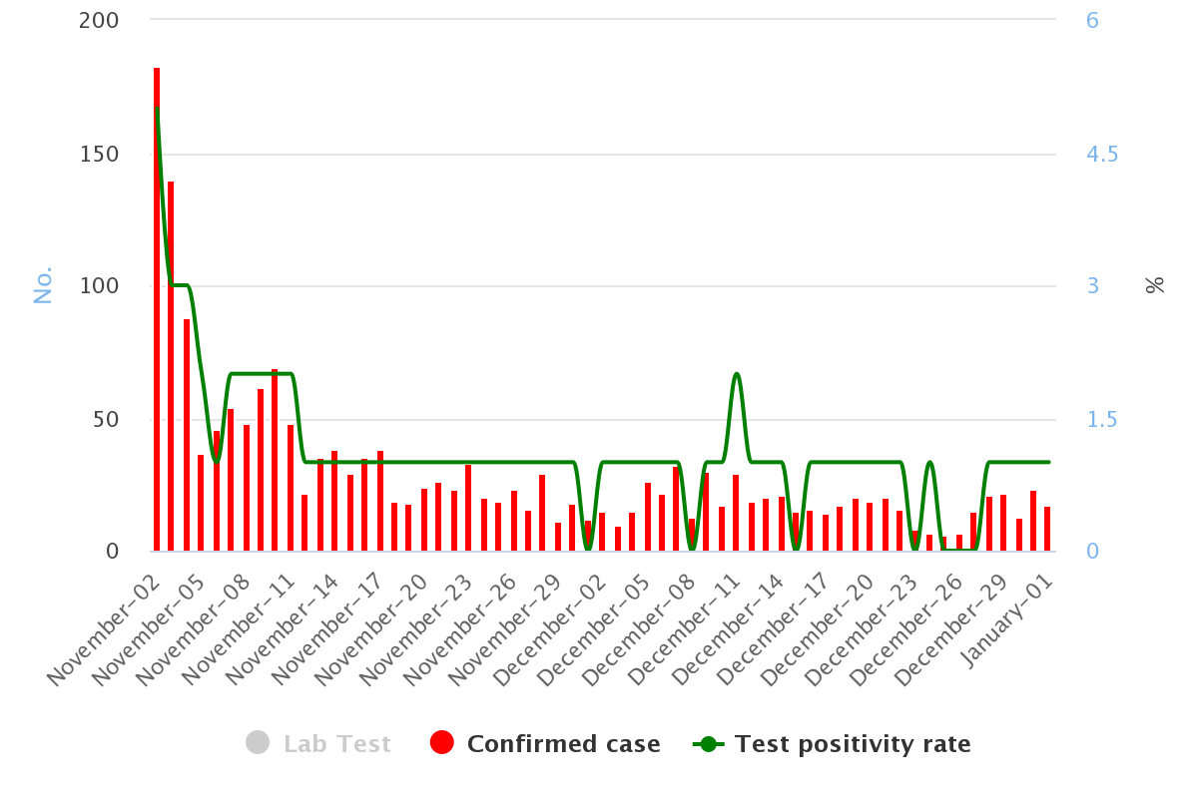

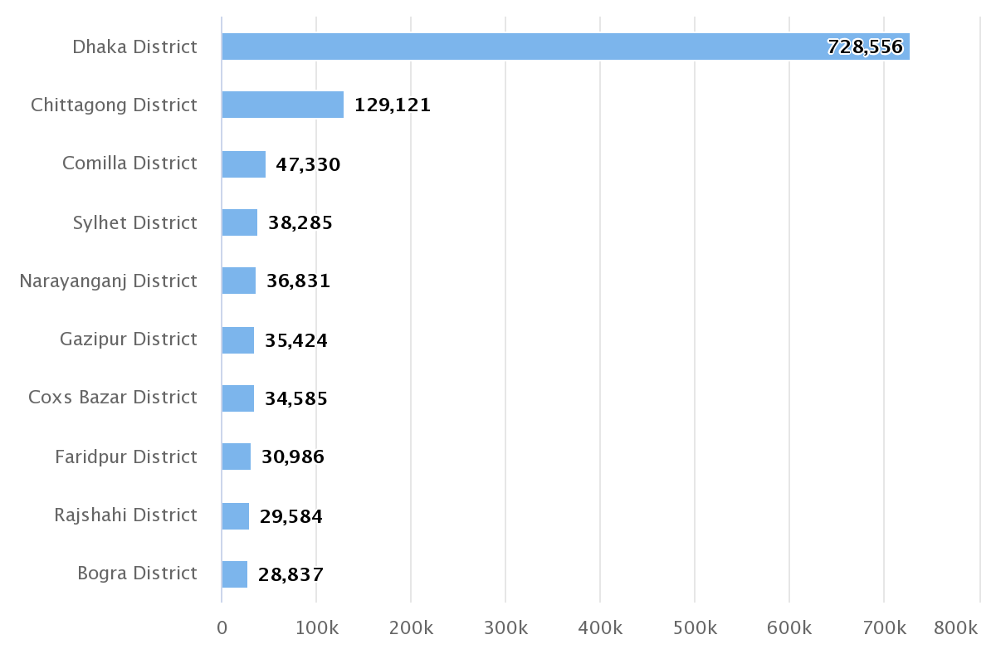

Supplementary Figure 2: COVID-19 status of Bnagladesh